**SDA LAB 3**

**BSE-4**

**K20-1052**

**Q1.**

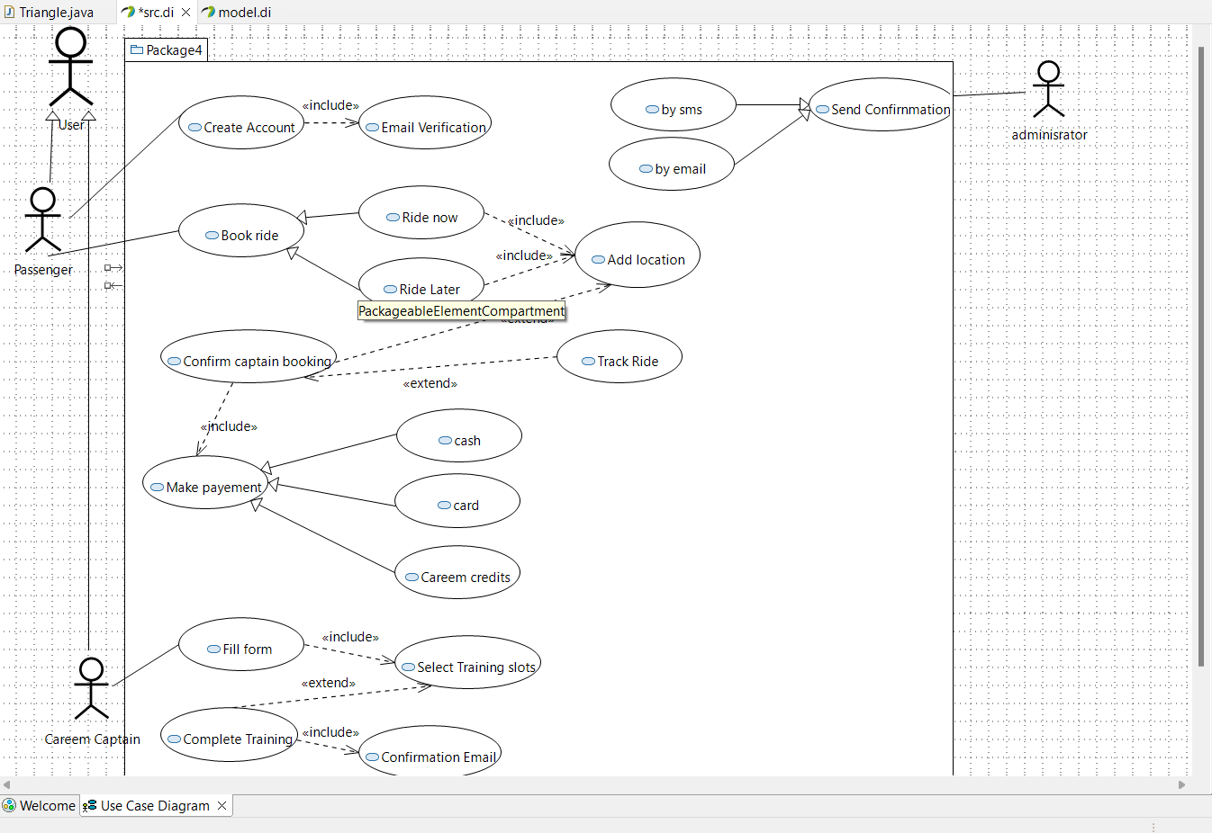

**Q2.**

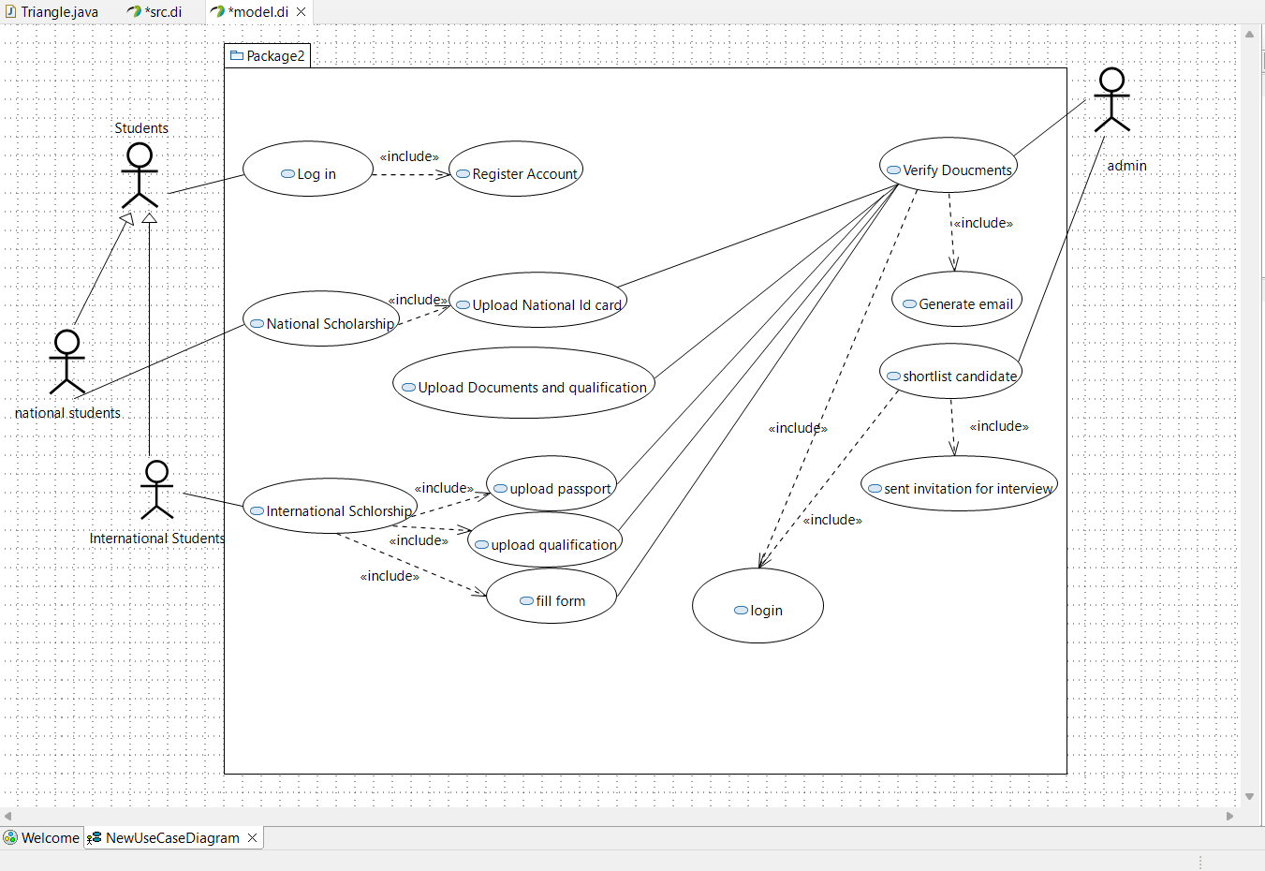

**Q3.**

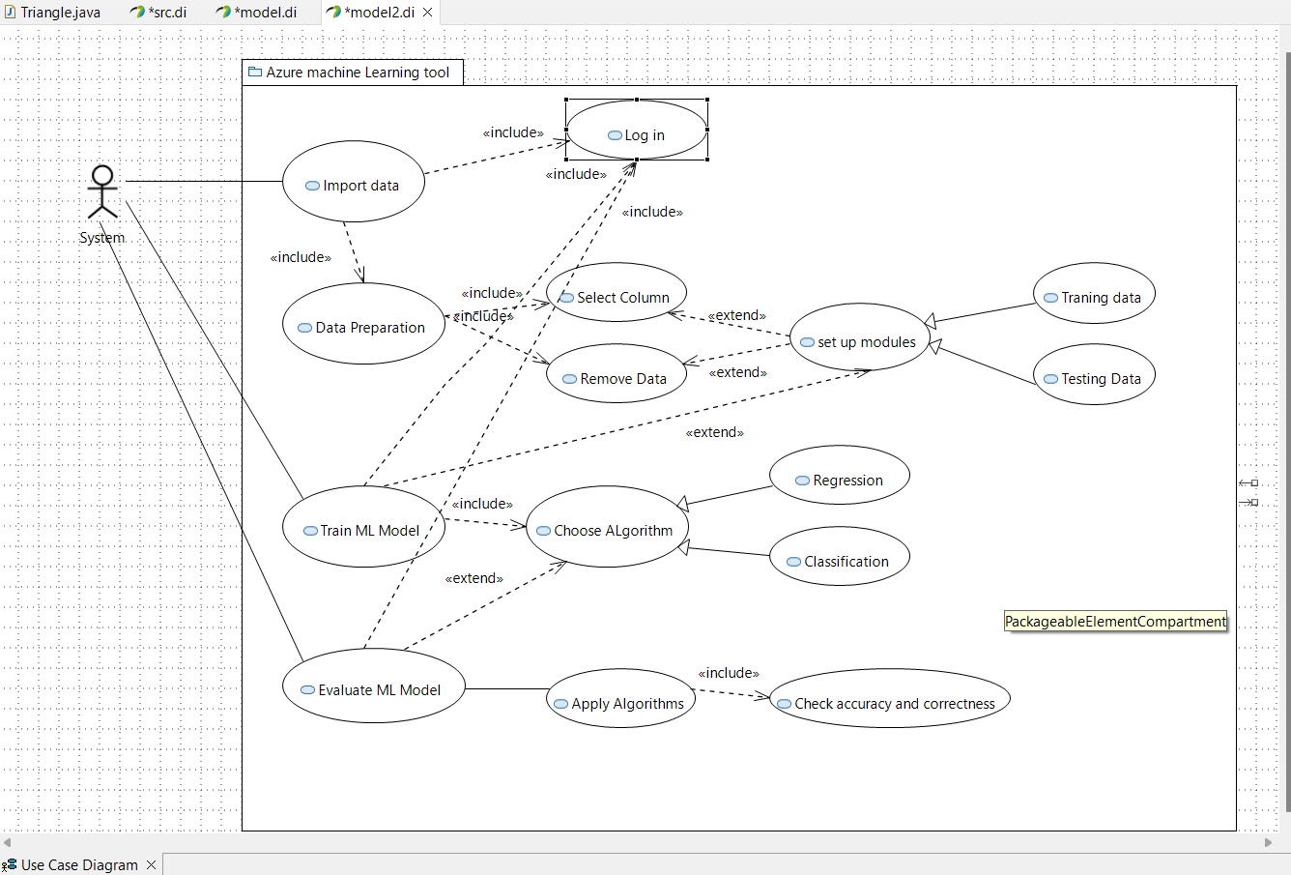

**Q4.**

User Story:

Business Airport International is the international review of the world's FBOs and general and business aviation airports for executive jet operators. A tour guide can group check-in along with the people he has come along. For the group check-in, individual check-in has to be done. A tour guide can also be a passenger who can do the individual check-in process by himself. The baggage of the passengers can be checked once they have a check-in. Passengers also have to go through security screening since the airport follows a security protocol.